Name: __Ashley Schuler_____________________
Student ID: __1234761387_________________
Date: ___25 February 25, 2026________________

Instructions: You should have at least three pages (3 html files and 1 css file) of your site completed by the time you submit this. Use the following to have a written discussion about the current progress of your website. After you answer the questions below, insert a screenshot of each of the pages you have completed so far (remember, you should have at least 4 and the CSS file). Do NOT screenshot the html code because we can’t run the code. Save the file to yourasurite – Project Assignment – Project Update 2.docx file and yourasurite – Project Assignment – Project Update 2.pdf file. Submit both files to Canvas.

- How do you feel your website is coming along? (10 points)

I feel like my website is coming along nicely. I am slowly but surely getting all the required elements for the assignment. I am trying to make sure my pages remain cohesive but simple so I think I am achieving that.

- Since your last update, have you encountered any issues? (4 points) If so, describe what they were and how you resolved them. (3 points) Are there any issues still unresolved? (3 points)

I am not really encountering any issues. I took the professor’s advice of getting some assistance and ideas from ChatGPT to help when I get stuck formatting parts of the website. My one unresolved issue is finding a standalone video in an mp4 format to utilize the video element. I was able to find a YouTube video to embed but I am still searching for a video to meet the assignment requirement.

- Your final project is almost done, outline what you have left and how you plan on completing it: (10 points)

For this project, as mentioned previously, I need to find a video for my site. I need to create and complete a form. I plan to create a planting schedule to satisfy this requirement and place it on my Plants page.

- List your project website's GitHub URL. (10 points)

aschuler08.github.io

- Videos can be a powerful tool on websites, helping to engage visitors by providing visual demonstrations, tutorials, product showcases, or entertainment. They can enhance the user experience by offering dynamic content that complements text and images. Videos are especially useful for conveying complex information in an easy-to-understand format.

Where would you like to use videos on your website? (2 points) How many videos will you include, and what videos will you create? (2 points) What do you hope to achieve with them (6 points)

I plan to use a video on my tools page. I think a video would be a great way to create a visual for site visitors to learn about gardening tools that would be helpful. I plan to include 1 but if I am unable to find an appropriate one, I will create a short video myself regarding garden tools.

- See your website’s readiness scores. Open your website in Chrome, right click your mouse to find Inspect. Click Inspect to find Lighthouse. Click Lighthouse to see the website’s readiness scores. Screenshot those scores and insert the Lighthouse report below: (10 points). The report should include performance, accessibility, Best Practices, and SEO scores.
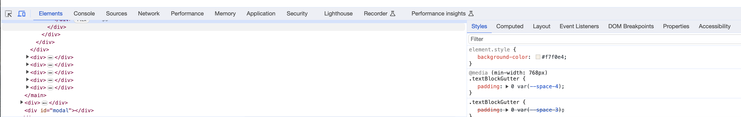

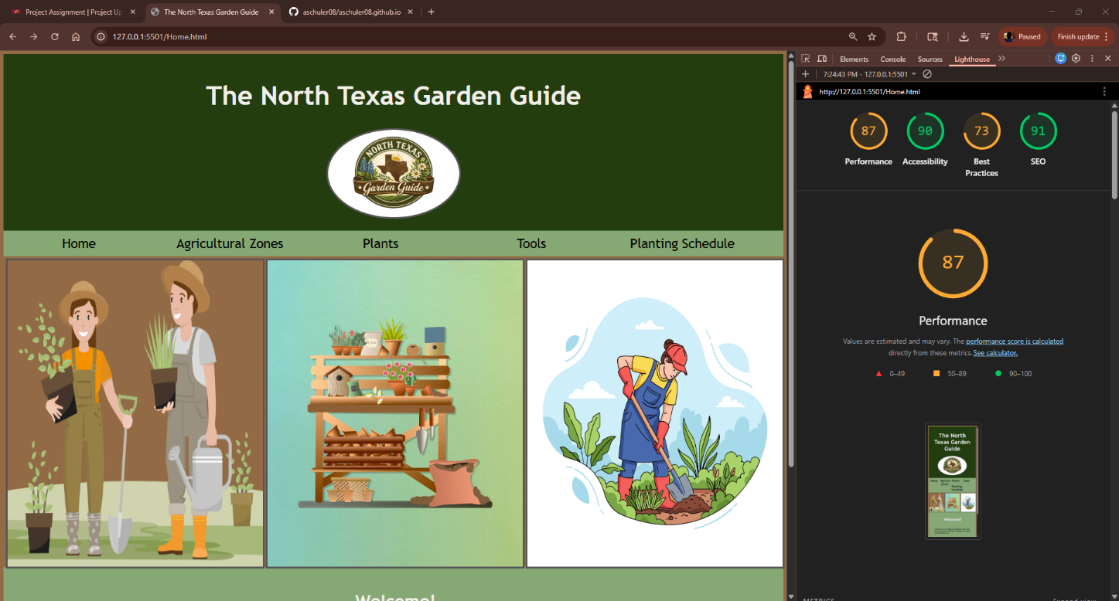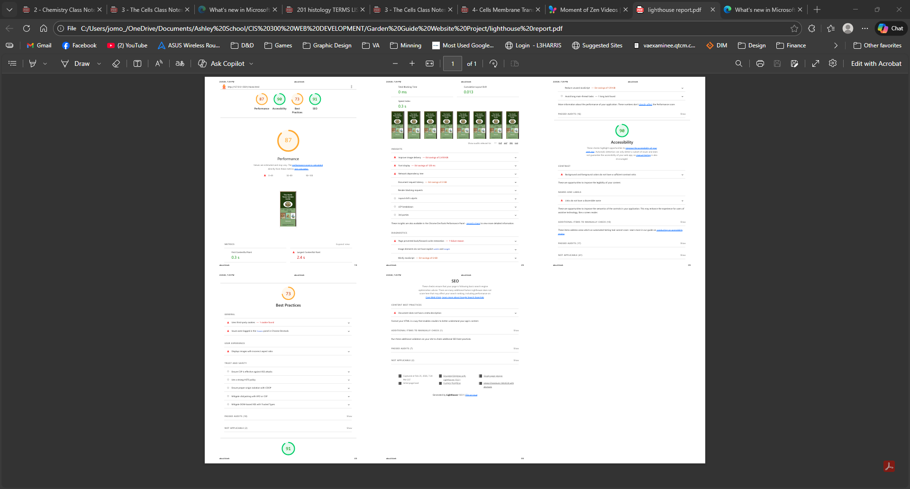

Web page browser view screenshot of Page #1 (10 points)
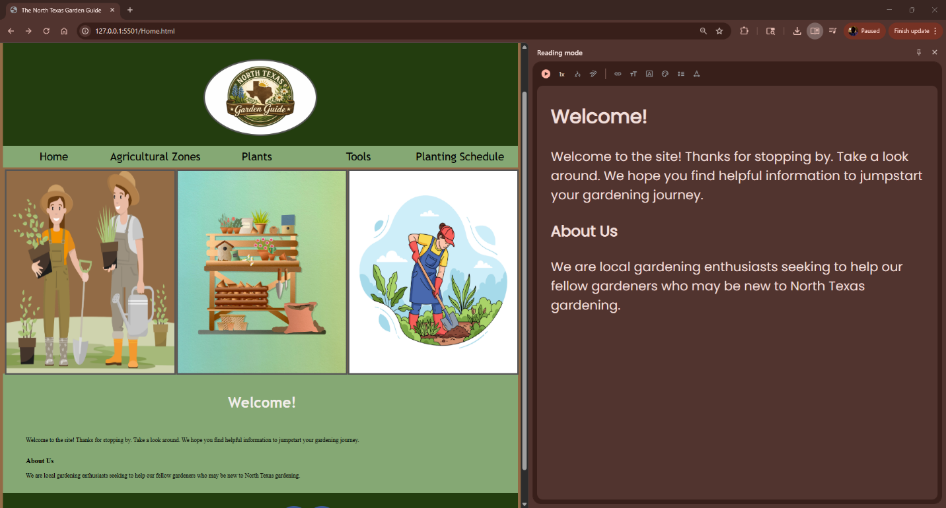
Web page browser view screenshot of Page #2 (10 points)
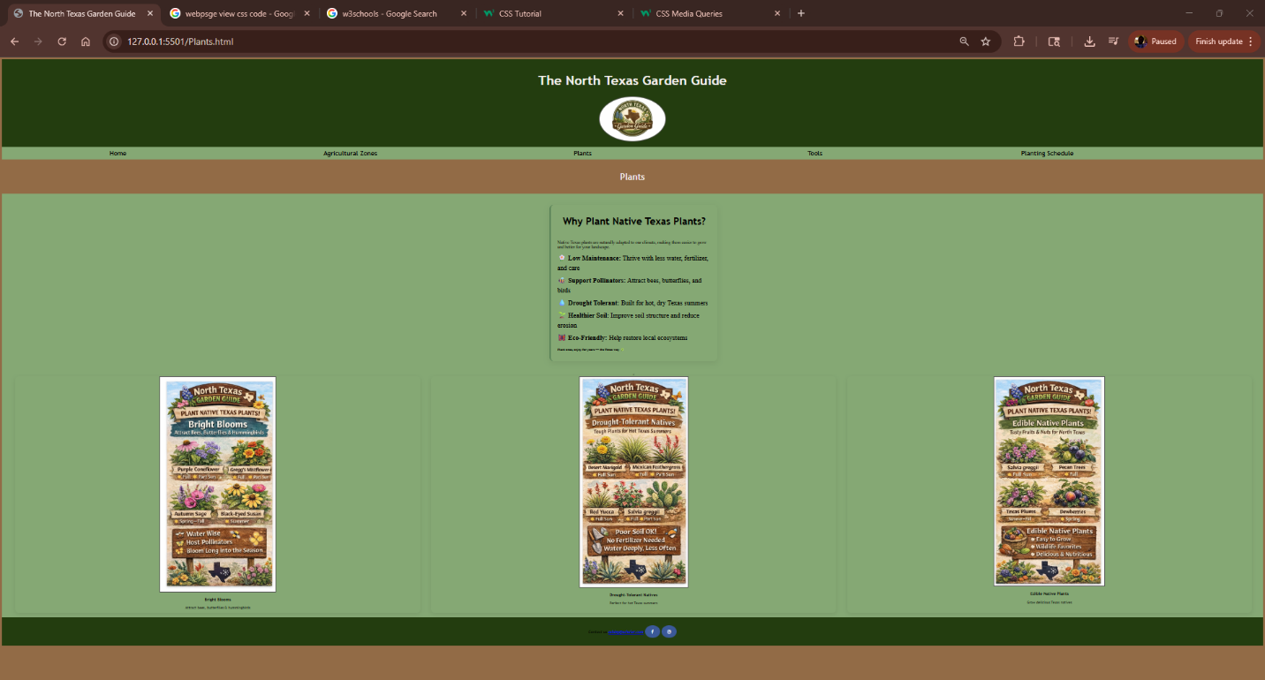
Web page browser view screenshot of Page #3 (10 points)
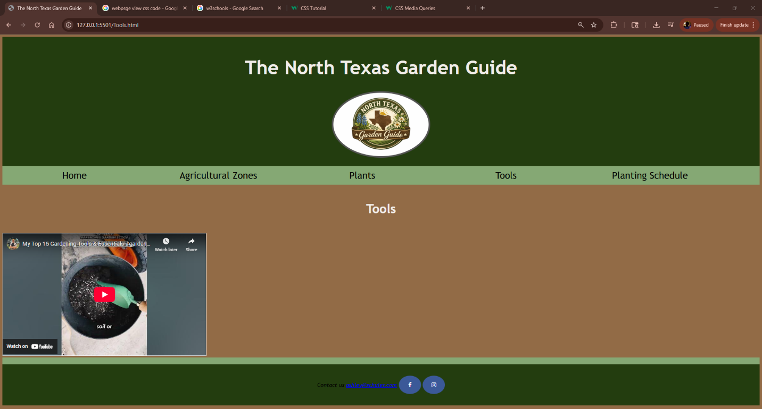

screenshot of the CSS code (10 points)




